TURKISH FORUM - DÜNYA TÜRKLERİ BİRLİĞİ
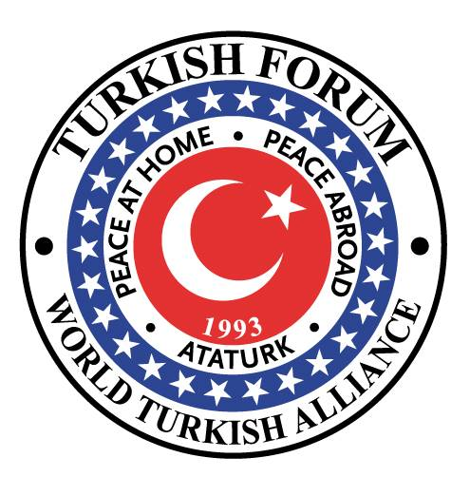
SOSYAL ARAŞTIRMALAR
ELEKTRONİK DERGİSİ

ÖZEL SAYI:
ÇANAKKALE ZAFERİNİN 100. YILINA ARMAĞAN

Cilt: 1 Sayı 1 Yıl: 2015

TURKISH FORUM - WORLD TURKISH ALLIANCE
SOCIAL SCIENCES
ELECTRONIC JOURNAL

SPECIAL ISSUE:
100th ANNIVERSARY OF THE GALLIPOLI VICTORY

Volume: 1 Issue: 1 Year: 2015

Turkish Forum- Dünya Türkleri Birliğinin Elektronik Yayın Organıdır

Electronic Publication of the Turkish Forum - the World Turkish Alliance

URL: http://www.turkishforum.com.tr

ISSN: (as of 2nd issue)

Indexed in ASOS

Dizgi /Design: Harun Taner

Kapak Dizaynı: Cover Design: Prof. Dr. Gül Celkan

Elektronik Baskı / Electronic Publication: Harun Taner

Basım yeri: Amerika Birleşik Devletlerl

Published in: United States of America

İletişim / for Contact: turkishforumyonetim@gmail.com

HAKEM KURULU / EDITORIAL BOARD

Dr. Kayaalp BÜYÜKATAMAN (Onursal Başkan)
Prof. Dr. Kemal ARI (9 Eylül Üniversitesi )
Prof. Dr. Turgut TURHAN (Doğu Akdeniz Üniversitesi)
Prof. Dr. Hüseyin UZUNBOYLU (Yakın Doğu Üniversitesi)
Prof. Dr. Ata ATUN (Yakın Doğu Üniversitesi)
Prof. Dr. Gul CELKAN (Middle Georgia State College)
Doç. Dr. Hasan CİCİOĞLU (Doğu Akdeniz Üniversitesi)
Yard. Doç. Dr. Altuğ GÜNAL (Ege Üniversitesi)

Yard. Doç. Dr. Alev GÖZCÜ (9 Eylül Üniversitesi)
Yard. Doç. Dr. Fevzi ÇAKMAK (9 Eylül Üniversitesi)
Yard. Doç. Dr. Doğan DUMAN (9 Eylül Üniversitesi)
Yard. Doç. Dr. Leyla KIRKPINAR (9 Eylül Üniversitesi)
Yard. Doç. Dr. Nurten ÇETIN, (Trakya Üniversitesi)
Dr. Turgay Bülent GÖKTÜRK (Doğu Akdeniz Üniversitesi)
Mrs. Tuba Angay CROWDER (Georgia State University)

ÖNSÖZ / PREFACE

Welcoming Remarks of the President and CEO of Turkish Forum-World Turkish Alliance

Turkish Forum - World Turkish Alliance ever since its inception in the year 1993 as a non-profit organization has always been at the service of the Turkish diaspora and friends of Turkey across the globe through its webpage, news websites, activities, publications and campaigns.

Our mission has always been to disseminate information about Turkey and other Turkish States, Turkish diaspora around the globe and raise awareness on issues related directly or indirectly to where Turks are living and hence fulfill our obligation, which is clearly explained in our founding principles.

Turkish Forum-World Turkish Alliance has always been of the belief that it should maintain a very dynamic structure and introduce novelties to its wide array of members, followers, friends and readers. With this in mind, we embarked on a new project: Social Sciences e-Journal. Needless to say, we are living in an age that moves at a very fast pace and we all have an insatiable thirst for knowledge. Given this fact, it becomes inevitable that this world of knowledge should be readily available and be at our fingertips regardless of its kind, and this belief has made digital publications gain priority.

As an organization, we are strictly devoted to the principles of Ataturk and secular Turkey, Thus we dedicated the first issue of Turkish Forum-World Turkish Alliance Social Sciences e-journal to the 100th Anniversary of Canakkale Victory. Following the letters sent out explaining our Journal and

call for contributions, articles, papers, essays started pouring in. Thanks to the selfless work of our Editorial Board, all works submitted were carefully reviewed and accepted for publication.

I would hereby like to thank all the contributors who made this journal become a reality and to everyone who made this publication possible, specially Managing editor Prof. Dr. Gul Celkan for the countless hours she spent on this first issue . Our peer-reviewed on-line Social Sciences Journal will be published twice a year where scholars, researchers, writers will find the proper medium to share their work in Turkish Forum’s indexed digital journal.

With due respect,

Dr. Kayaalp BUYUKATAMAN
BAŞ EDİTÖR’UN NOTU / EDITOR-IN-CHIEF’S NOTE
It is with great pleasure that we release our first edition of the Turkish Forum-World Turkish Alliance Social Sciences E-Journal. Our guiding principle in undertaking this work has been to diversify the activities and services rendered by Turkish Forum to not only the Turkish people but to friends of the Turkish peoples across the globe.
When the idea of embarking on this new venture came up, we had our fears, doubts but it didn’t take us long to overcome these because we had confidence in ourselves. We know that to succeed, we have to take certain risks, and the famous saying, “Success belongs to those who dare to achieve it” (Ataturk) has been our motto throughout the entire process.
This publication is first of its kind, and despite that, when we shared the call for articles message through various means with the world of academia, we were stunned to see how faculty members offered help make this publication become a reality. We are so grateful to all of them.
Our starting point was the 100th Anniversary of the Canakkale Victory. We had kept questioning ourselves how we could make this year a memorable one from the stand point of the Turkish Forum. And thus was born the idea of publishing an online journal dedicated to this remarkable point in Turkish History. We received a good number of articles or writings by professionals from varied backgrounds, and the editorial board found the 20 articles, 5 of which were in the English language, three poems and accounts of a travel across the Dardanelles Strait relevant to the purpose of this first issue.
Coming up with ideas needs very good collaboration and cooperation. It is

worthwhile mentioning at this point that we have a very harmonious group led by Dr. Kayaalp Buyukataman, the President & CEO of the Turkish Forum, who was readily available at every phase of the entire ordeal to solve any problem, major or minor, so as to make this publication become a reality.

The Turkish Forum-World Turkish Alliance Social Sciences E-Journal will be published twice a year and will accept papers in all areas included in social sciences. We are proud to say that our journal is currently indexed in ASOS, the social sciences index, and this will follow by others once the first edition goes on the world wide web through our webpage www.turkishforum.com.tr.

We hope you enjoy reading each and every work in this first issue. The perspectives the writers had and the stories they shared about this Victory are worth the praise.

Respectfully yours
Dr. Gul Celkan

İÇİNDEKİLER / TABLE OF CONTENTS

ÖNSÖZ

BAŞ EDİTÖRÜN NOTU

BÖLÜM 1: MAKALELER

Prof. Dr. Kemal Ari
Çanakkale’de 57. Alay ve Mustafa Kemal Bey

Prof. Dr. Kemal Ari
The 57th Regiment and Mustafa Kemal in Canakkale

Prof. Dr. Turgut Turhan
Çanakkale Savaşlarında Türk Havacıları

Yard. Doç. Dr. Necdet Aysal
Çanakkale Savaşlari (1915) Yard. Doç. Dr. Necdet Aysal

Yard. Doc. Dr. Alev Gozcu
The Sinking of Saphir, the French Submarine, in Gallipoli Front and Turkish Propaganda

Ahmet Akyol (E. Top. Kur. Yb)
Çanakkale Zaferi’nin Mimari Türkler mi, Almanlar mi?

Assist. Prof. Dr. Nurten Çetin,
Çanakkale Martyrs From Karaman

Ahmet Akyol (E. Top. Kur. Yb)
Mustafa Kemal’in Çanakkale Muharebeleri’ndeki Rolü

Prof. Dr. Kemal Ari
Çanakkale Savaşinda Açlik Ve Tokluk...

Doç. Dr. Hasan Cicioğlu
Savaşa Nasıl Girdik?
Dr. Turgay Bülent Göktürk
Çanakkale Muharebelerinin Türk Ve Dünya Tarihi Açısından
Değerlendirilmesi

Aydan Dizdar
Çanakkale Savaşı’nı Kazandıran Yüksek Ruh

Prof. Dr. Gül Celkan
Çanakkale Savaşının Edebiyatta Yansımaları

BÖLÜM 2: FIKRA YAZILARI

Prof. Dr. Turgut Turhan

Çanakkale Denizalti Savaşlari

Gazimağusa ve Çanakkale Şehitliği

Çanakkale Savaşinda Uçak (Taşima) Gemileri ve Sabit
Balonlar

Çanakkale Savaşinin Pek Bilinmeyen Bir Yönü : Balonlar --Çanakkale Savaşi Günlerinde İstanbul

Çanakkale Zaferinin 95. Yılı Ve General Ian Hamilton’ in
Çanakkale’de Yaşadığı Düş Kırıklığı

97. Yıldönümünde Çanakkale Savaşları Ve İngiltere

Prof. Dr. Gul Celkan

Some Reflections on Literature, War Poetry with Emphasis on the
Canakkale Victory

BÖLÜM 3: ÇANAKKALE İLE İLGİLİ ANI YAZILARI

Bora Hincer
Orhan Pamuk – Anzac Day – Panama Kanali

BÖLÜM 3: ŞİİRLER

Alev Necile Dinc

Atatürk

Çanakkale Şehitleri

Mehmetcik

" Those heroes that shed their blood and
lost their lives...! You are now lying in
the soul of a friendly country, therefore
rest in peace. There is no differences between
the Johnnies and the Mehmets to us where they
lie side by side here in this country of ours...
You, the mothers who sent their sons from far away
countries wipe away your tears. Your sons are now
lying in our bosom and are in peace. After having
lost their lives on this land they have become
our sons as well."
ATATURK, (1934)

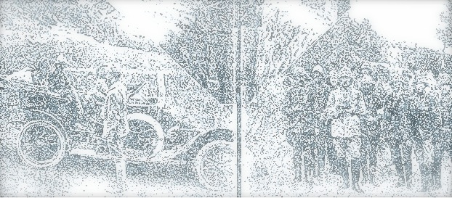

They went with songs to the battle, they were young.
Straight of limb, true of eyes, steady and aglow.
They were staunch to the end against odds uncounted,
They fell with their faces to the foe.
They shall grow not old, as we that are left grow old:
Age shall not weary them, nor the years condemn.
At the going down of the sun and in the morning,
We will remember them.
Laurence Binyon (1869-1943)

